Weapon Classes, Types and Variants Guide

Video guide can be found here:
https://www.youtube.com/watch?v=gk4xpbmp2xY

Last Updated : Y2025 - M12 - D28

Weapon Classes, Types and Variants

There are a lot of weapons in Division 2. I subdivide them into weapon classes, such as AR, SMG, Lmg etc… .Then there are weapon types, this is my term for weapon archetypes within categories, such as the MK16 as a whole. But then there are several MK16 with different names, and each separate version of those i call variants.
So it goes Class -> Type -> Variant. There is no uniformity in this as some use these terms interchangeably, but this is the structure we will be following for this guide.
Classes

Each class of weapons has inherent traits and stats, as for instance ARs are inherently more accurate than SMGs, and LMGs inherently suppress enemies more so than other classes. So comparing between classes means looking at both its stats, handling and traits.

Common traits of each class are :
ARs : Fairly accurate, general workhorses.
SMGs : Shorter range, poor accuracy, good damage at short range.
LMGs : Larger magazine sizes, become more accurate while firing, will suppress more than other classes
Rifles : Accurate, but harder to handle for most, fairly weak damage.
Shotguns : Short effective range, high damage at short range.
Pistols : Always available, not effective for longer range engagements.
MMRs : Hard hitting but slow firing, great effective range.

Types

And then there are many types within each class, each type has its own characteristics, but each type has the same hard stats.
Hard stats are any stats that we have ingame stated data for, things such as Base damage, RPM and magazine size amongst others are considered hard stats.
Things that are less definable with a hard number like handling in general, which beyond just the accuracy and stability stats are also dependent on recoil pattern, which is testable, but not easy to outright define as a metric.

Variants must have the same hard stats to be considered in the same Type, if any hard stat like amount of mods or base damage is different, that would make it a different type.
Making it so that weapons like the AKM versus blackmarket or military AKM are different Types not Variants.

Variants

Variants then are the separate weapons sharing hard stats, but have different values for some of the soft stats, like accuracy or stability.

And then it is important to know which of those variants are the better picks, as between variants of the same gun there can be minor changes, mostly this manifests as slight handling differences between variants, and usually one can be said to be the preferred pick. In this guide I will lay out which I consider the better variants.
This guide

In this guide I will show all weapons types in each class, and they are in order by how much I would recommend them, so the higher a weapon in a class section, the better i consider it to be, and this includes not just looking at the weapons burst and sustain DPS’s, but also it handling or other traits.

The following graphics are all with a build with no weapon handling, with no handling mods on the weapon itself, on a character that has the watch filled in, meaning there is 10 accuracy ,10 stability and 10 Reload speed active.

Assault Rifles

Lexington Type.  1 Variant.  Note : Type based on M4, Has 3.8% higher base and slightly different recoil pattern | 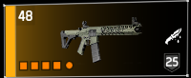
 | 
-Long Optics Rail
-5.56 Magazine Slot
-Long Underbarrel Rail
-5.56 Muzzle Slot

Famas Type.  1 Variant. | 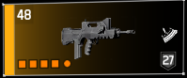
a | 
-Long Optics Rail
-5.56 Magazine Slot
-Short Underbarrel Rail
-5.56 Muzzle Slot

FAL Type.  3 Variants.  Para preferred.  Very slight handling differences between Sa58’s, and a bigger jump to the big FAL | 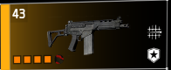 | 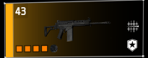 | 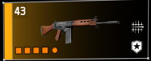
 |  |  | 
 | -Long Optics Rail  -7.62 Magazine Slot  -Long Underbarrel Rail  -7.62 Muzzle Slot | -Long Optics Rail  -7.62 Magazine Slot  -Long Underbarrel Rail  -7.62 Muzzle Slot | -Long Optics Rail  -7.62 Magazine Slot  -Long Underbarrel Rail  -7.62 Muzzle Slot

CTAR Type.  1 Variant. | 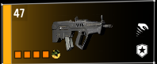
 | 
-Short Optics Rail
-5.56 Magazine Slot
-Side Slot
-5.56 Muzzle Slot

F2000 Type.  1 Variant. | 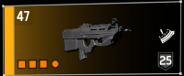
 | 
-Optics Rail
-5.56 Magazine Slot
-x
-5.56 Muzzle Slot

P416 Type.  2 Variants.  Custom preferred.  Very slight handling differences between them. | 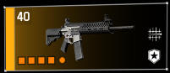 | 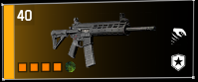
 |  | 
 | -Optics Rail  -5.56 Magazine Slot  -Long Underbarrel Rail  -5.56 Muzzle Slot | -Optics Rail  -5.56 Magazine Slot  -Long Underbarrel Rail  -5.56 Muzzle Slot

Honey Badger Type.  1 Variant. | 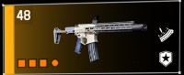
 | 
-Long Optics Rail
-5.56 Magazine Slot
-Long Underbarrel Rail
-x

Police M4 Type.  1 Variant. | 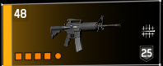
 | 
-Long Optics Rail
-5.56 Magazine Slot
-Long Underbarrel Rail
-5.56 Muzzle Slot

G36 Type.  3 Variants.  Enhanced preferred.  Slight handling differences between them.  Note : Enhanced and Military have long underbarrel rail, G36C has short. | 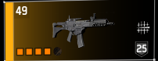 | 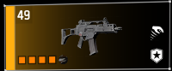 | 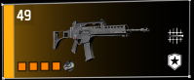
 |  |  | 
 | -Long Optics Rail  -5.56 Magazine Slot  -Long Underbarrel Rail  -5.56 Muzzle Slot | -Long Optics Rail  -5.56 Magazine Slot  -Short Underbarrel Rail  -5.56 Muzzle Slot | -Long Optics Rail  -5.56 Magazine Slot  -Long Underbarrel Rail  -5.56 Muzzle Slot

First Sight Type.  1 Variant.  Note : Type based on AK-M, +30 Headshot Damage, but worse Reload. | 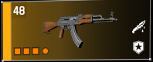
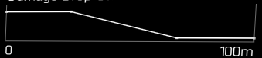 | 
-Long Optics Rail
-7.62 Magazine Slot
-Short Underbarrel Rail
-x

Aug Type.  1 Variant. | 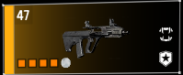
 | 
-Optics Rail
-5.56 Magazine Slot
-Short Underbarrel Rail
-5.56 Muzzle Slot

Carbine 7 Type.  1 Variant. | 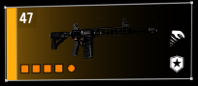
 | 
-Long Optics Rail
-5.56 Magazine Slot
-Long Underbarrel Rail
-5.56 Muzzle Slot

PDR Type.  1 Variant. | 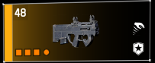
 | 
-Short Optics Rail
-5.56 Magazine Slot
-x
-5.56 Muzzle Slot

SIG 556 Type.  1 Variant. | 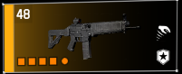
 | 
-Long Optics Rail
-5.56 Magazine Slot
-Short Underbarrel Rail
-5.56 Muzzle Slot

MK16 Type.  3 Variants.  Socom preferred.  Slight handling differences between Socom and mk16, Tactical has quite a different handling feel. | 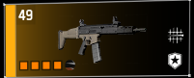 | 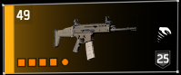 | 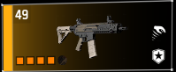
 |  |  | 
 | -Optics Rail  -5.56 Magazine Slot  -Long Underbarrel Rail  -5.56 Muzzle Slot | -Optics Rail  -5.56 Magazine Slot  -Long Underbarrel Rail  -5.56 Muzzle Slot | -Optics Rail  -5.56 Magazine Slot  -Long Underbarrel Rail  -5.56 Muzzle Slot

ACR Type.  2 Variants.  ACR-E heavily preferred.  Pretty big handling differences between them.  Note : One of the bigger differences that exists between variants. | 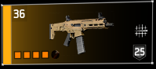 | 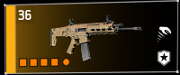
 |  | 
 | -Optics Rail  -5.56 Magazine Slot  -Long Underbarrel Rail  -5.56 Muzzle Slot | -Optics Rail  -5.56 Magazine Slot  -Long Underbarrel Rail  -5.56 Muzzle Slot

AK-M Type.  1 Variant. | 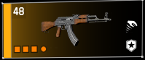
 | 
-Long Optics Rail
-7.62 Magazine Slot
-Short Underbarrel Rail
-x

AK-M Type.  2 Variants.  Black Market preferred.  Very slight handling differences between them. | 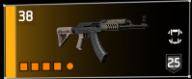 | 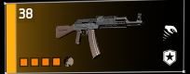
 |  | 
 | -Long Optics Rail  -7.62 Magazine Slot  -Long Underbarrel Rail  -7.62 Muzzle Slot | -Long Optics Rail  -7.62 Magazine Slot  -Long Underbarrel Rail  -7.62 Muzzle Slot

TKB Type.  1 Variant. | 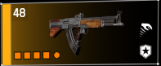
 | 
-Long Optics Rail
-7.62 Magazine Slot
-Long Underbarrel Rail
-7.62 Muzzle Slot

Sub Machine Guns

Tac Vector Type.  1 Variant. | 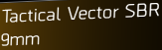  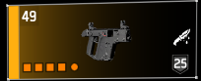
 | 
-Optics Rail
-9mm Magazine Slot
-Short Underbarrel Rail
-9mm Muzzle Slot

Converted SMG-9 Type.  1 Variant. | 
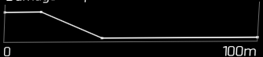 | 
-Short Optics Rail
-9mm Magazine Slot
-x
-9mm Muzzle Slot

Vector 9mmType.  1 Variant. | 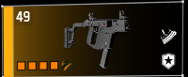
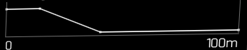 | 
-Optics Rail
-9mm Magazine Slot
-Short Underbarrel Rail
-9mm Muzzle Slot

Converted SMG-9 A2 Type.  1 Variant. | 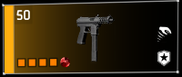
 | 
-Short Optics Rail
-9mm Magazine Slot
-Short Underbarrel Rail
-9mm Muzzle Slot

Vector 45 Type.  1 Variant. | 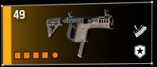
 | 
-Optics Rail
-.45 ACP Magazine Slot
-Long Underbarrel Rail
-.45 ACP Muzzle Slot

MP7 Type.  1 Variant. | 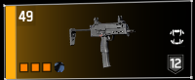
 | 
-Long Optics Rail
-x
-Short Underbarrel Rail
-5.56 Muzzle Slot

Sig MPX Type.  1 Variant. | 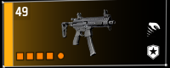
 | 
-Long Optics Rail
-9mm Magazine Slot
-Short Underbarrel Rail
-9mm Muzzle Slot

PP19 Type.  2 Variants.  Enhanced preferred.  Slight handling differences between them. | 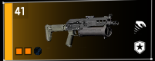 | 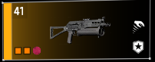
 |  | 
 | -Long Optics Rail  -x  -x  -9mm Muzzle Slot | -Long Optics Rail  -x  -x  -9mm Muzzle Slot

M1928 Type.  1 Variant. | 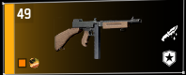
 | 
-x
-.45 ACP Magazine Slot
-x
-x

MP5 Type.  3 Variants.  ST preferred.  Very slight handling differences between them.  Note : ST and N have long underbarrel rail, A2 has short. | 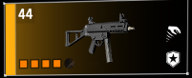 |  | 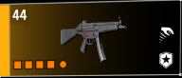
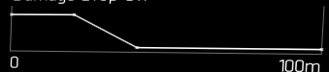 |  |  | 
 | -Optics Rail  -9mm Magazine Slot  -Long Underbarrel Rail  -9mm Muzzle Slot | -Short Optics Rail  -9mm Magazine Slot  -Long Underbarrel Rail  -9mm Muzzle Slot | -Long Optics Rail  -9mm Magazine Slot  -Short Underbarrel Rail  -9mm Muzzle Slot

T821 Type.  2 Variants.  Police Preferred.  Very slight handling differences between them. | 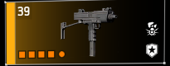 | 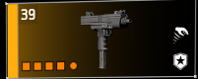
 |  | 
 | -Short Optics Rail  -9mm Magazine Slot  -Short Underbarrel Rail  -9mm Muzzle Slot | -Short Optics Rail  -9mm Magazine Slot  -Short Underbarrel Rail  -9mm Muzzle Slot

Slingshot Type.  1 Variant.  Note : Type based on Tactical UMP, Has 60 Optimal Range base. | 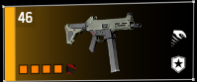
 | 
-Long Optics Rail
-.45 ACP Magazine Slot
-Long Underbarrel Rail
-.45 ACP Muzzle Slot

CMMG Banshee Type.  1 Variant. | 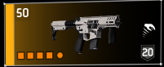
 | 
-Short Optics Rail
-9mm Magazine Slot
-Short Underbarrel Rail
-9mm Muzzle Slot

P90 Type.  1 Variant. | 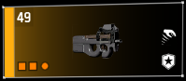
 | 
-Short Optics Rail
-x
-x
-9mm Muzzle Slot

Tommy Gun Type.  1 Variant. | 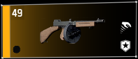
 | 
-x
-x
-x
-x

Aug Type.  3 Variants.  Enhanced preferred for long rail.  Tactical preferred for handling.  Very slight handling differences between them.  Note : Enhanced and Para XS have long underbarrel rail, Tactical has short. | 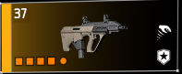 | 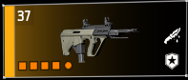 | 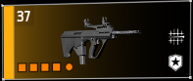
 |  |  | 
 | -Optics Rail  -9mm Magazine Slot  -Short Underbarrel Rail  -9mm Muzzle Slot | -Optics Rail  -9mm Magazine Slot  -Long Underbarrel Rail  -9mm Muzzle Slot | -Optics Rail  -9mm Magazine Slot  -Long Underbarrel Rail  -9mm Muzzle Slot

UMP Type.  2 Variants.  Tactical preferred.  Very slight handling differences between them. |  | 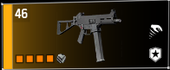
 |  | 
 | -Long Optics Rail  -.45 ACP Magazine Slot  -Long Underbarrel Rail  -.45 ACP Muzzle Slot | -Long Optics Rail  -.45 ACP Magazine Slot  -Long Underbarrel Rail  -.45 ACP Muzzle Slot

Light Machine Guns

MG5 Type.  1 Variant. | 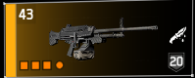
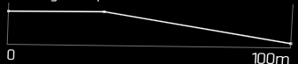 | 
-Long Optics Rail
-Ammunition Belt Slot
-Short Underbarrel Rail
-x

MK46/M249 Type.  3 Variants.  MK46 preferred.  Slight handling differences between them. | 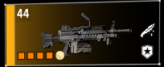 | 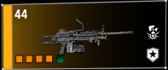 | 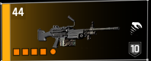
 |  |  | 
 | -Long Optics Rail  -Ammunition Belt Slot  -Long Underbarrel Rail  -5.56 Muzzle Slot | -Long Optics Rail  -Ammunition Belt Slot  -Long Underbarrel Rail  -5.56 Muzzle Slot | -Long Optics Rail  -Ammunition Belt Slot  -Long Underbarrel Rail  -5.56 Muzzle Slot

Infantry MG5 Type.  2 Variants.  Infantry MG5 preferred.  Bell ringer ONLY has a different firing sound. BELL RINGER SHOULD NEVER BE USED UNLESS YOU WANT TO BE HATED. 3rd place out of 2 variants. | 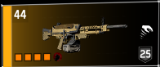 |  | 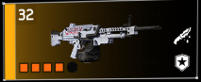
 |  |  | 
 | -Long Optics Rail  -Ammunition Belt Slot  -Short Underbarrel Rail  -7.62 Muzzle Slot |  | -Long Optics Rail  -Ammunition Belt Slot  -Short Underbarrel Rail  -7.62 Muzzle Slot

Negev Type.  1 Variant. | 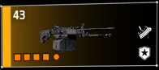
 | 
-Short Optics Rail
-Ammunition Belt Slot
-Long Underbarrel Rail
-7.62 Muzzle Slot

RPK Type.  3 Variants.  Black Market preferred.  Slight handling differences between them. | 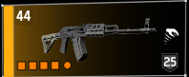 | 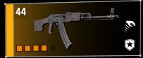 | 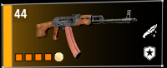
 |  |  | 
 | -Long Optics Rail  -7.62 Magazine Slot  -Long Underbarrel Rail  -7.62 Muzzle Slot | -Long Optics Rail  -7.62 Magazine Slot  -Long Underbarrel Rail  -7.62 Muzzle Slot | -Long Optics Rail  -7.62 Magazine Slot  -Long Underbarrel Rail  -7.62 Muzzle Slot

GR9 Type.  1 Variant. | 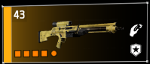
 | 
-Optics Rail (Locked:5 CHC)
-Ammunition Belt Slot
-Short Underbarrel Rail
-7.62 Muzzle Slot

Classic M60 Type.  1 Variant. | 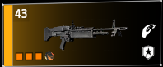
 | 
-Long Optics Rail
-Ammunition Belt Slot
-Long Underbarrel Rail
-x

M60 E# Type.  2 Variants.  E6 preferred.  Slight handling differences between them. | 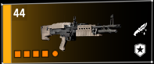 | 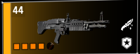
 |  | 
 | -Long Optics Rail  -Ammunition Belt Slot  -Long Underbarrel Rail  -7.62 Muzzle Slot | -Long Optics Rail  -Ammunition Belt Slot  -Long Underbarrel Rail  -7.62 Muzzle Slot

L86 Type.  2 Variants.  Custom preferred.  Very Slight handling differences between them.  Note : Custom has long underbarrel rail, Military has short. | 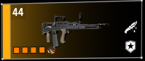 | 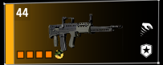
 |  | 
 | -Long Optics Rail  -5.56 Magazine Slot  -Long Underbarrel Rail  -5.56 Muzzle Slot | -Long Optics Rail  -5.56 Magazine Slot  -Short Underbarrel Rail  -5.56 Muzzle Slot

Stoner Type.  1 Variant.  Note : Muzzle slot is fixed to accuracy mod. | 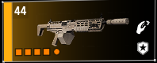
 | 
-Long Optics Rail
-Ammunition Belt Slot
-Short Underbarrel Rail
-Muzzle Slot (Locked:30 Stab)

Rifles

MK17 Type.  2 Variants.  Police preferred.  Very slight handling differences between them. | 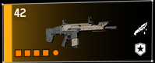 | 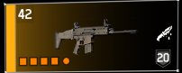
 |  | 
 | -Long Optics Rail  -7.62 Magazine Slot  -Long Underbarrel Rail  -7.62 Muzzle Slot | -Long Optics Rail  -7.62 Magazine Slot  -Long Underbarrel Rail  -7.62 Muzzle Slot

1886 Type.  1 Variant. | 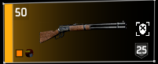
 | 
-x
-Tubular Magazine Slot
-x
-x

SIG CQB Type.  1 Variant. | 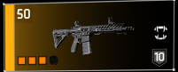
 | 
-Long Optics Rail
-7.62 Magazine Slot
-Short Underbarrel Rail
-x

M16 Type.  1 Variant. | 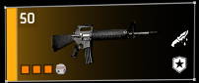
 | 
-Short Optics Rail
-5.56 Magazine Slot
-x
-5.56 Muzzle Slot

SIG 716 Type.  1 Variant. | 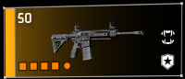
 | 
-Long Optics Rail
-7.62 Magazine Slot
-Long Underbarrel Rail
-7.62 Muzzle Slot

UIC Type.  1 Variant. | 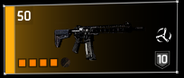
 | 
-Long Optics Rail
-5.56 Magazine Slot
-Long Underbarrel Rail
-5.56 Muzzle Slot

Classic M1A Type.  1 Variant. | 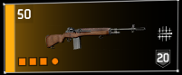
 | 
-Long Optics Rail
-Marksman 7.62 Magazine Slot
-Long Underbarrel Rail
-x

ACR SS Type.  1 Variant. | 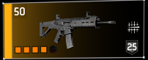
 | 
-Long Optics Rail
-7.62 Magazine Slot
-Long Underbarrel Rail
-7.62 Muzzle Slot

M1A Type.  2 Variants.  CQB preferred.  Slight handling differences between them. | 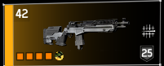 | 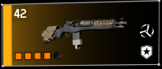
 |  | 
 | -Long Optics Rail  -Marksman 7.62 Magazine Slot  -Long Underbarrel Rail  -7.62 Muzzle Slot | -Long Optics Rail  -Marksman 7.62 Magazine Slot  -Long Underbarrel Rail  -7.62 Muzzle Slot

Lightweight M$ Type.  1 Variant. | 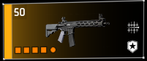
 | 
-Optics Rail
-5.56 Magazine Slot
-Long Underbarrel Rail
-5.56 Muzzle Slot

LVOA-C Type.  1 Variant. | 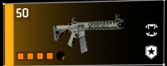
 | 
-Optics Rail
-5.56 Magazine Slot
-Long Underbarrel Rail
-5.56 Muzzle Slot

MK47 Type.  1 Variant. | 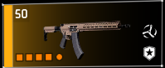
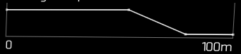 | 
-Long Optics Rail
-7.62 Magazine Slot
-Long Underbarrel Rail
-7.62 Muzzle Slot

MDR Type.  1 Variant. | 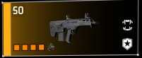
 | 
-Long Optics Rail
-7.62 Magazine Slot
-Long Underbarrel Rail
-7.62 Muzzle Slot

USC 45 Type.  1 Variant. | 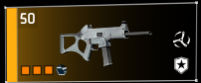
 | 
-Long Optics Rail
-.45 ACP Magazine Slot
-Long Underbarrel Rail
-x

Shotguns

SASG-12 Type.  3 Variants  Black Market preferred.  Slight handling differences between them. |   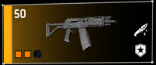 | 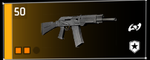 | 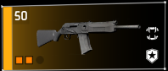
 |  |  | 
 | -Long Optics Rail  -x  -Long Underbarrel Rail  -x | -Short Optics Rail  -x  -Long Underbarrel Rail  -x | -Short Optics Rail  -x  -Long Underbarrel Rail  -x

Super 90 Type.  3 Variants.  Tactical preferred.  Very slight handling differences between them. | 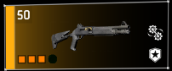 | 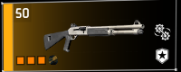 | 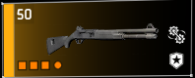
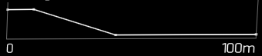 |  |  | 
 | -Long Optics Rail  -Tubular Magazine Slot  -Long Underbarrel Rail  -x | -Long Optics Rail  -Tubular Magazine Slot  -Long Underbarrel Rail  -x | -Long Optics Rail  -Tubular Magazine Slot  -Long Underbarrel Rail  -x

M870 Type.  3 Variants.  Custom & Military preferred.  Slight handling differences between them.  Note : Military has short optics rail which allows for higher headshot mods | 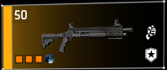 | 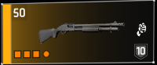 | 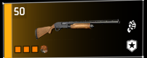
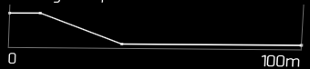 |  |  | 
 | -Long Optics Rail  -Tubular Magazine Slot  -Long Underbarrel Rail  -x | -Short Optics Rail  -Tubular Magazine Slot  -Long Underbarrel Rail  -x | -Long Optics Rail  -Tubular Magazine Slot  -Long Underbarrel Rail  -x

Stack Broker Type.  1 Variant.  Note : Type based on ACS-12, Has 20% higher Rate of Fire base, and 20% less Base Damage. | 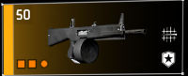
 | 
-Short Optics Rail
-x
-Long Underbarrel Rail
-x

ACS Type.  1 Variant. | 
 | 
-Short Optics Rail
-x
-Long Underbarrel Rail
-x

Six-Twelve Type.  1 Variant. | 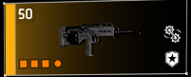
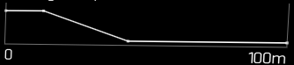 | 
-Short Optics Rail
-Tubular Magazine Slot
-Long Underbarrel Rail
-x

SPAS Type.  1 Variant. | 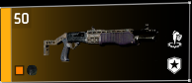
 | 
-x
-Tubular Magazine Slot
-x
-x

KSG Type.  1 Variant. | 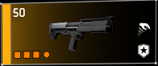
 | 
-Short Optics Rail
-Tubular Magazine Slot
-Long Underbarrel Rail
-x

DB Shotgun Type.  1 Variant. | 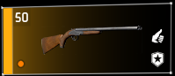
 | 
-x
-x
-x
-x

Double Barrel Sawed Off Type.  1 Variant. |   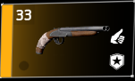
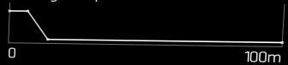 | 
-x
-x
-x
-x

Pistols

KARD-45 Type.  1 Variant. | 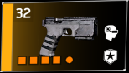
 | 
-Micro Optics Rail
-Pistol Magazine Slot
-Gadget Slot
-9mm Muzzle Slot

The Harvest Type.  1 Variant.  Note : Type based on 686 Magnum, Higher Base damage, slower RPM. | 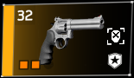
 | 
-Short Optics Rail
-Revolver Drum Slot
-x
-x

Tac m1911 / M45 Type.  2 Variants.  Tactical m1911 preferred. | 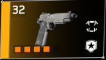 | 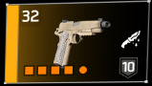
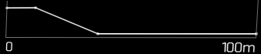 |  | 
 | -Micro Optics Rail  -Pistol Magazine Slot  -Gadget Slot  -.45 Muzzle Slot | -Micro Optics Rail  -Pistol Magazine Slot  -Gadget Slot  -.45 Muzzle Slot

Magnum Type.  2 Variants.  Police 686 preferred. | 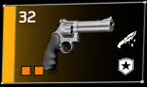 | 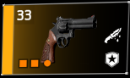
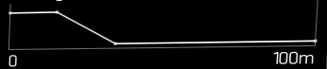 |  | 
 | -Short Optics Rail  -Revolver Drum Slot  -x  -x | -Short Optics Rail  -Revolver Drum Slot  -x  -x

M1911 Type.  1 Variant. | 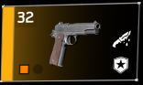
 | 
-x
-Pistol Magazine Slot
-x
-x

X-45 Type.  2 Variants.  X-45 Tactical preferred. | 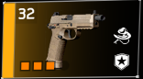 | 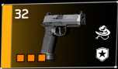
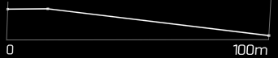 |  | 
 | -x  -Pistol Magazine Slot  -Gadget Slot  -.45 Muzzle Slot | -x  -Pistol Magazine Slot  -Gadget Slot  -.45 Muzzle Slot

93R Type.  1 Variant. | 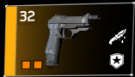
 | 
-x
-Pistol Magazine Slot
-x
-9mm Muzzle Slot

First Wave PF45 Type.  1 Variant. | 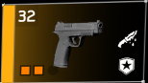
 | 
-x
-Pistol Magazine Slot
-Gadget Slot
-x

Custom PF45 Type.  1 Variant. | 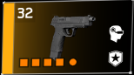
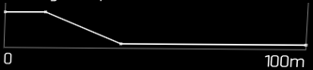 | 
-Micro Optics Rail
-Pistol Magazine Slot
-Gadget Slot
-.45 Muzzle Slot

Px4 Type.  2 Variants.  Type T preferred. | 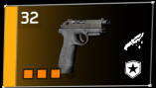 | 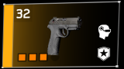
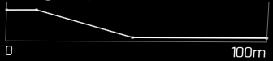 |  | 
 | -c  -Pistol Magazine Slot  -Gadget Slot  -.45 Muzzle Slot | -c  -Pistol Magazine Slot  -Gadget Slot  -9mm Muzzle Slot

D50 Type.  1 Variant. | 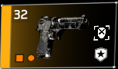
 | 
-Short Optics Rail
-x
-x
-x

Diceros Type.  1 Variant. | 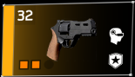
 | 
-x
-Revolver Drum Slot
-Gadget Slot
-x

Snub. Diceros Type.  1 Variant. | 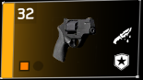
 | 
-x
-Revolver Drum Slot
-x
-x

Officer’s M9 Type.  1 Variant. | 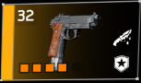
 | 
-Micro Optics Rail
-Pistol Magazine Slot
-Gadget Slot
-9mm Muzzle Slot

M9 Type.  1 Variant. | 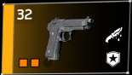
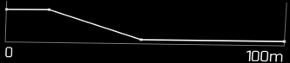 | 
-x
-Pistol Magazine Slot
-x
-9mm Muzzle Slot

MarksMan Rifles

White Death Type.  1 Variant.  Note : Type based on M44 Carbine, Higher Base Headshot. | 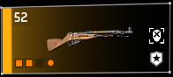
 | 
-Long Optics Rail
-Integrated Magazine Slot
-Short Underbarrel Rail
-x

Handbasket Type.  1 Variant.  Note : Type based on Surplus SVD, Has Much higher base damage and heavily reduced RPM. | 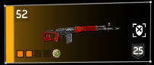
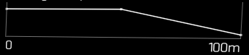 | 
-Long Optics Rail
-Marksman 7.62 Magazine Slot
-Short Underbarrel Rail
-7.62 Muzzle Slot

Custom M44 Type.  1 Variant. | 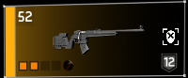
 | 
-Long Optics Rail
-Marksman 7.62 Magazine Slot
-Long Underbarrel Rail
-7.62 Muzzle Slot

M700 Type.  2 Variants.  Carbon preferred.  Slight handling differences between them.  Note : Tactical can not use stab/acc mods in underbarrel. | 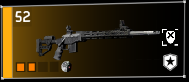 | 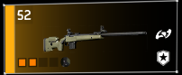 | 4
 |  |  | 8
 | -Long Optics Rail  -Marksman 7.62 Magazine Slot  -Long Underbarrel Rail  -7.62 Muzzle Slot | -Long Optics Rail  -Marksman 7.62 Magazine Slot  -Side Slot  -7.62 Muzzle Slot

SRS Type.  2 Variants.  A1 preferred.  Almost no handling differences between them. | 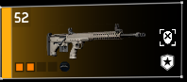 | 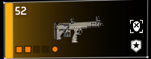 | 4
 |  |  | 8
 | -Optics Rail  -Marksman 7.62 Magazine Slot  -Long Underbarrel Rail  -7.62 Muzzle Slot | -Optics Rail  -Marksman 7.62 Magazine Slot  -Short Underbarrel Rail  -7.62 Muzzle Slot

SR-1 Type.  1 Variant. | 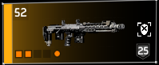
 | 
-Optics Rail
-Marksman 7.62 Magazine Slot
-Short Underbarrel Rail
-7.62 Muzzle Slot

Tac .308 Type.  1 Variant. | 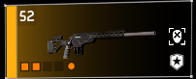
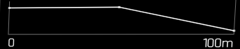 | 
-Long Optics Rail
-Marksman 7.62 Magazine Slot
-Long Underbarrel Rail
-7.62 Muzzle Slot

Model 700 Type.  1 Variant. | 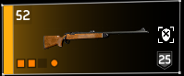
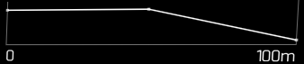 | 
-Long Optics Rail
-Integrated Magazine Slot
-x
-7.62 Muzzle Slot

Hunting M44 Type.  1 Variant. | 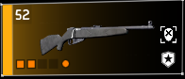
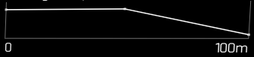 | 
-Long Optics Rail
-Integrated Magazine Slot
-Long Underbarrel Rail
-7.62 Muzzle Slot

Classic M44 Type.  1 Variant. | 
 | 
-Long Optics Rail
-Integrated Magazine Slot
-Short Underbarrel Rail
-x

SVD Type.  2 Variants.  Paratrooper preferred.  Slight handling differences between them. Different recoil pattern. | 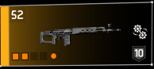 | 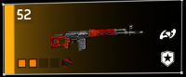 | 4
 |  |  | 8
 | -Long Optics Rail  -Marksman 7.62 Magazine Slot  -Short Underbarrel Rail  -7.62 Muzzle Slot | -Long Optics Rail  -Marksman 7.62 Magazine Slot  -Short Underbarrel Rail  -7.62 Muzzle Slot

G28 Type.  1 Variant. | 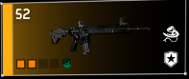
 | 
-Long Optics Rail
-7.62 Magazine Slot
-Long Underbarrel Rail
-7.62 Muzzle Slot

MK20 Type.  1 Variant. | 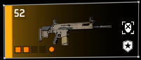
 | 
-Optics Rail
-7.62 Magazine Slot
-Long Underbarrel Rail
-7.62 Muzzle Slot

DPS tables

Some of the decision on ranking these is based upon the dps tables found here:
https://drive.google.com/drive/folders/1dBD1oKXzJB1E3bMJtfRNxRHoDCtkkZy8

But the rankings are not solely based on dps tables, they include my experience running all these weapons, and do account for things like how well a weapon handles, or if it has traits that adversely affect usage.

Links to my other guides, the Build Collection, DMG/DPS Calculators and many other things:

https://docs.google.com/document/d/15mg-_sjowh5_8bUp2VIBqnDxCDqz-xJOISl0DlG3RDU

